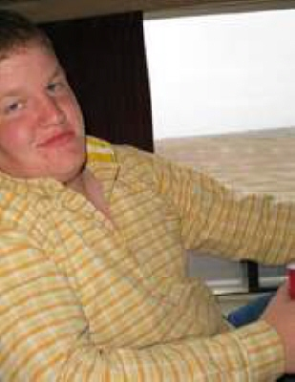 Mark Green
Wrestling Scholarship

Mark Alan Green was born March 20, 1990, to Marvin Green and Debra (Pitner) Urban and passed from this earth on January 23, 2022.

Mark enjoyed the world of agriculture and pursued this by following a career as a farmer and rancher south of Atwood on the family farm. However, perhaps his greatest joy came from his nephews and niece whom he loved to tease, play, and spend time with. He was a terrific uncle.

While he was quiet by nature, Mark was quick with a joke and always had a story to tell. Once you started him talking, he would devote hours to a good conversation. Along with uncle, he also proudly carried the titles of son, brother, cousin, nephew and friend.

Mark Alan Green is still loved on earth by his mother Debra (Scott) Urban; father Marvin (Kathy) Green: sisters, Sarah Maaske, Amy Kastens and Jade Green (Damian Kocher); brother Cody (Kelsey) Green; nephews, Aiden and August Maaske, Holt Green and Finn Kocher; niece Baize Kastens and a niece expected in February to Cody and Kelsey; as well as many aunts, uncles, cousins, and friends. We will continue to love and miss him.

“God looked down on his planned paradise and said, “I need a caretaker” So God made a farmer.”

REQUIREMENTS:
All seniors who participated in Rawlins County High School Wrestling and earned a varsity letter are eligible and encouraged to apply for this scholarship. Preference will be given to wrestlers.
Applicants need to be involved in the community.
The minimum GPA requirements shall be 2.5; however, the highest GPA shall not determine the scholarship recipient.
Further consideration will be given to the student’s strength of character, sportsmanship, selflessness, etc.
The intended use of the scholarship can include tuition, books, or vocational trade expenses.
Applications must be completed in full. Any failure to do so may result in the application not being considered.

Please return it to the RCHS School Counselor by April 15th.

This scholarship recipient will be decided by a selection committee. The recipient will be receiving the scholarship at the Rawlins County High School Awards Ceremony held at the RCHS in May.

Directions for applying:

Write a paragraph about what you intend to study in college and a paragraph about a life lesson you learned from your experiences on the wrestling mat. Attach it to this document and return it to the RCHS school counselor by April 15th.

